Chapter 5 Homework Problems

Problem 5.1

Use the method of joints to solve for the forces in each member of the lifting gantry truss shown below.

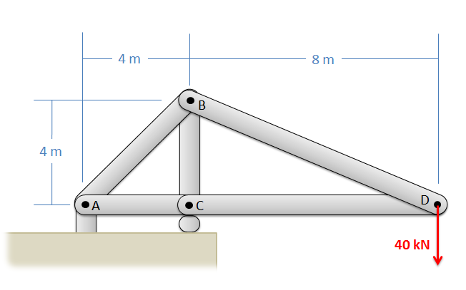

Solution: FAB = 113.14 kN T, FAC = 80 kN C, FBC = 120 kN C, FBD = 89.44 kN T, FCD = 80 kN C

Problem 5.2

The truss shown below is supported by two cables at A and E, and supports two lighting rigs at D and F, as shown by the loads. Use the method of joints to determine the forces in each of the members.

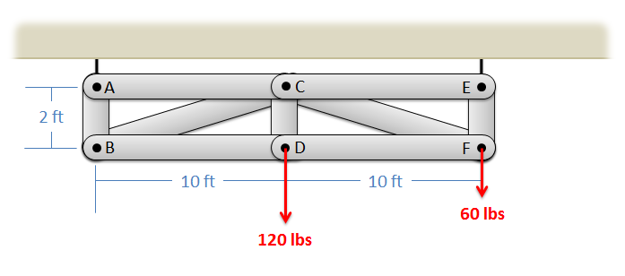

Solution: FAB = 60 lbs T, FAC = 0, FBC = 305.94 lbs C, FBD = 300 lbs T, FCD = 120 lbs T, FCE = 0,

FCF = 305.94lbs C, FDF = 300 lbs T, FEF = 120 lbs T

Problem 5.3

The space truss shown below is being used to lift a 250 lb box. The truss is anchored by a ball and socket joint at C (which can exert reaction forces in the x, y, and z directions) and supports at A and B that only exert reaction forces in the y direction. Use the method of joints to determine the forces acting all members of the truss.

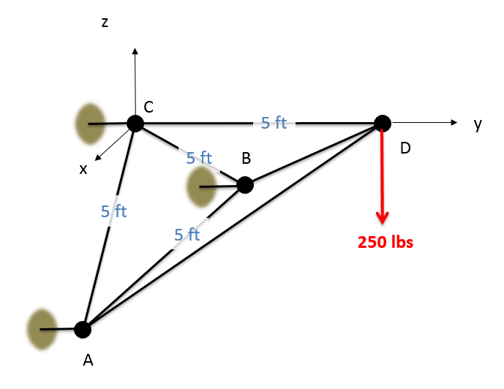

Solution: FAB = 0, FAC = 144.33 lbs T, FAD = 204.09 lbs C, FBC = 144.33 lbs T, FBD = 204.09 lbs C,

FCD = 288.68 lbs T

Problem 5.4

Use the method of sections to solve for the forces acting on members CE, CF, and DF of the gantry truss shown below.



Solution: FCE = 0, FCF = 306.2 lbs C, FDF = 300.2 lbs T

Problem 5.5

You are asked to compare two crane truss designs as shown below. Find the forces in members AB, BC, and CD for Design 1 and find forces AB, AD, and CD for Design 2. What member is subjected to the highest loads in either case?

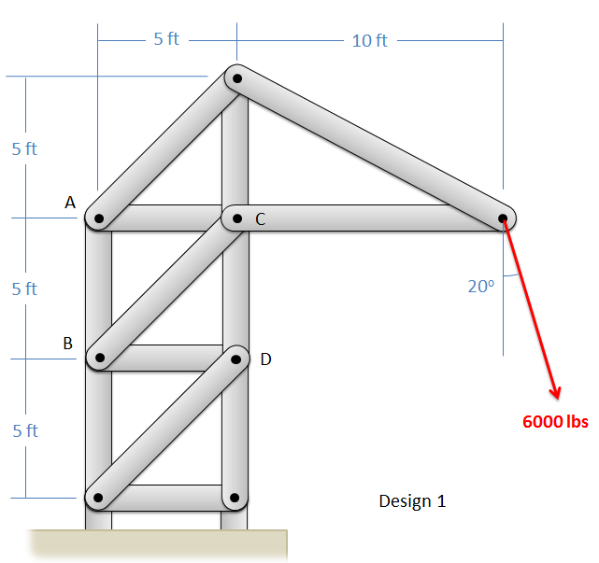 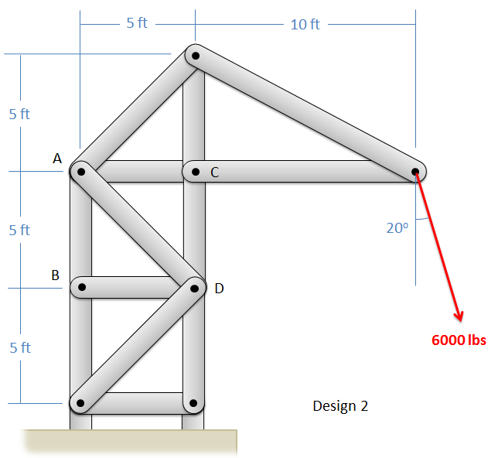

Solution: Design 1: FAB = 11,276 lbs T, FBC = 2,902 lbs T, FCD = 18,967 lbs C Design 2: FAB = 13,322 lbs T,

FAD = 2902 lbs C, FCD = 16,914 lbs C. The largest forces are in member CD for both designs.

Problem 5.6

The truss shown below is supported by a pin support at A and a roller support at B. Determine the forces in members CE, CF, and CD.

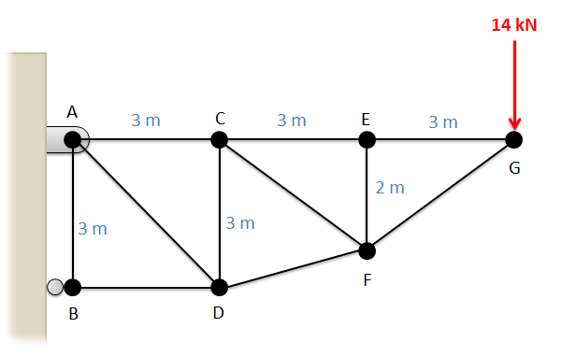

Solution: FCE = 21 kN T, FCF = 8.41 kN T, FCD = 4.67 kN C

Problem 5.7

The shelf shown below is used to support a 50 lb weight. Determine the forces on members ACD and BC in the structure. Draw those forces on diagrams of each member.

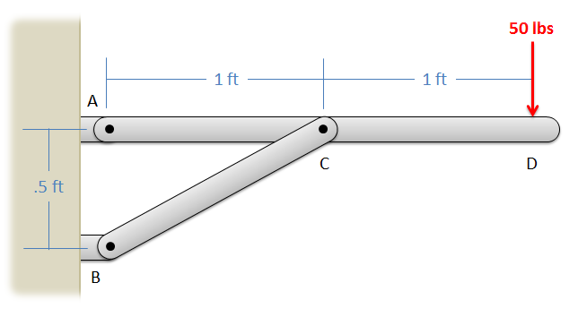

Solution: FBC = 227.7 lbs, FAX = -203.7 lbs, FAY = -51.8 lbs

Problem 5.8

A 20 N force is applied to a can crushing mechanism as shown below. If the distance between points C and D is .1 meters, what are the forces being applied to the can at points B and D?

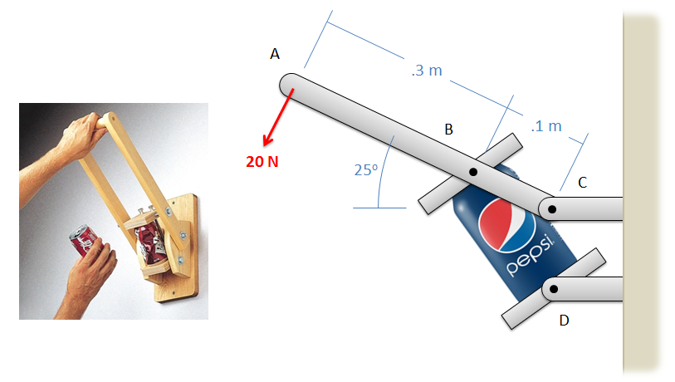

Solution: Fcan = 148.9 N

Problem 5.9

The chair shown below is subjected to forces at A and B by a person sitting in the chair. Assuming that normal forces exist at F and G, and that friction forces only act at point G (not at F), determine all the forces acting on each of the three members in the chair. Draw these forces acting on each part of the chair on a diagram

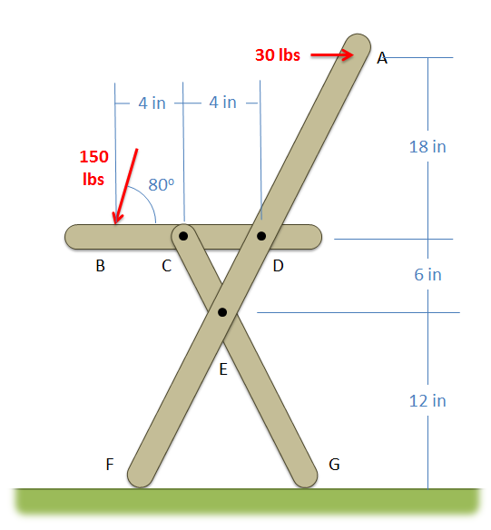

Solution: FF = 108.3 lbs, FGX = - 3.95 lbs, FGY = 39.5 lbs, FCX = ± 116.89 lbs, FCY = ± 295.4 lbs,

FDX = ±142.9 lbs, FDY = ±147.7 lbs, FEX = ± 112.9 lbs, FEY = ±256.0 lbs